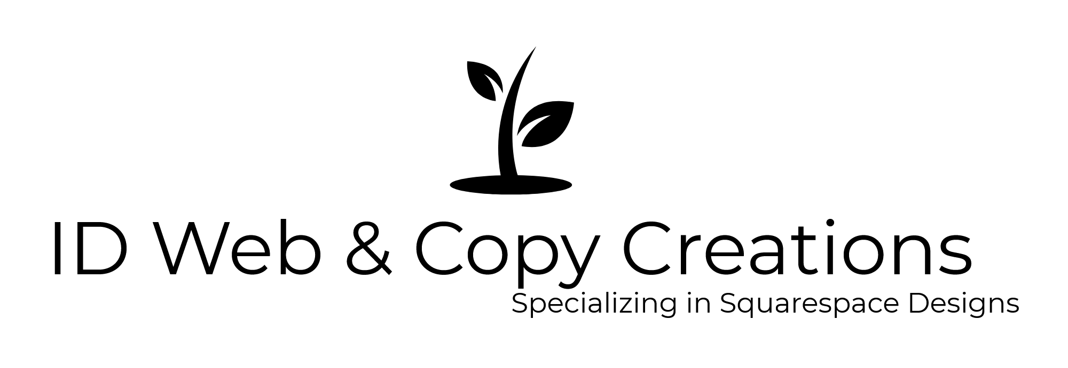

Web Design Project Questionnaire

Name:

Email:

Phone:

Please complete all questions that are applicable to this project.

Basic

Do you currently have a website? If so, what’s the address? (If not, leave blank).

Do you want me to arrange hosting?

Do you currently have a logo?

Do you currently have any written and/or image content? If so, please describe.

Would you like to engage me to perform all applicable copywriting/copyediting services for your site?

Do you need me to locate suitable third-party image assets (e.g., Pixabay, Unsplash or other downloadable image sites) image for the site?

Objectives

What is the website’s primary purpose?

Do you want any of the following?

- Blog?
- Social sharing icons?
- Links to social profiles?
- Email signup form / ability to collect email addresses?
- Ability to sell digital products?
- Ability to sell physical products?
- Other?

Your Brand

Who is the website’s target audience?

Additional Information

How many pages will the website have roughly?

Please list the navigation menu options (if you already know).

Ideally, when would you like the website completed?

Two or three websites you admire or would like to emulate:

Additional Comments/Requests

Contact:

Ian Dogole
ID Web & Copy Creations
415.383.7120
globalfusion@comcast.net
www.idwebcopycreations.com

